**Software Development Cycle Workbook**

Software Development Lifecycle (SDLC)

| A process used by the software industry to produce high-quality systems that meet or exceed the customer’s expectations. |
| --- |

Phases of SDLC

| 1.  A - Business Analysis  B - Requirements Analysis |
| --- |
| 2.  Design |
| 3.  Development/Coding |
| 4.  Testing |
| 5.  Deployment |
| 6.  Maintenance |

| **1A— Business**  **Analysis** | What is the current state? |
| --- | --- |
| **1B— Requirements Analysis** | Customer describes what they want and how they want it used. |
| **2— Design** | How do we build it? Look at both HLD and LLD for full picture. |
| **3— Development Coding** | Actual coding phase |
| **4— Testing** | Test software for bugs and against the requirements initially set out. |
| **5— Deployment** | Service goes live and can be used by end- user |
| **6—Maintenance** | Ongoing process for updates, upgrades, and new features |

| High-level Design | List of the functional aspects of the modules and final result |
| --- | --- |
| . macroLow-level  Design | Details the logic and execution micro vs macro |

| User  Experience  Testing | How easy is it to use? |
| --- | --- |
| Functionality Testing | Does it do what it is designed to do? |
| Security  Testing | Does it meet clients acceptable risk profile |
| Load  Testing | Will the number of users be able to be supported and maintained |
| Performance Testing | Will live performance meet expectations |
| Compatibility Testing | Will it be compatible once release/ will other outside variables impact the program |

What is the importance of ensuring users are properly trained?

Allows the team to ensure proper use/ understanding of software and a more successful launch

Why does this training need to occur before rollout?

You run the risk of users not being properly trained when using and failure of launch

What is meant by “deploy into the live environment''?

Available for use by the end-user

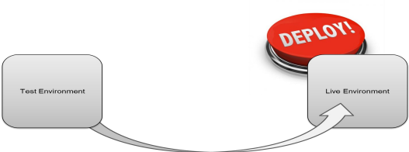

What steps are necessary after deployment into the live environment to allow users to utilize the new functionality?

You must maintain your software to make sure that any unfound bugs are fixed based on the software being live and interacting with other programs. Also any needed updates or upgrades. For example adding a new security feature because there is a new trojan horse being spread.